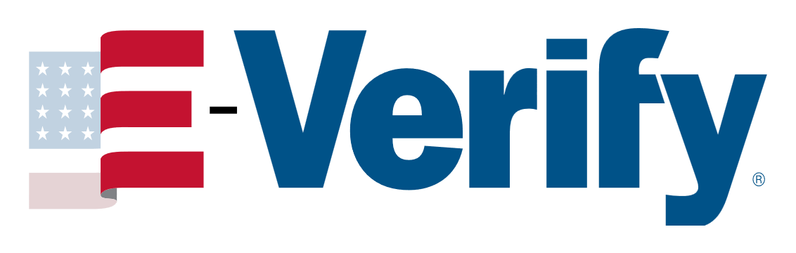


Capability Statement
Corporation Legal Name: Bitfastt Inc. State of Incorporation: New York
CAGE: 9K2U9
D-U-N-S®: 062533253
NAICS: 541511, 541519, 511210, 334111, 334118

Overview

Bitfastt Inc. is an IT solutions and services provider supporting Federal Government agencies, as well as the Education and Healthcare markets. We deliver solutions for Cybersecurity, MultiCloud, DevSecOps, Big Data, Artificial Intelligence, Open Source, Customer Experience, and others. Working with systems integrators, contracting officers, senior defense personnel, and c-suite executives, we provide industry-leading IT products, services, and training through government-wide acquisition contracts. We’re committed to the success of our partners from edge to cloud. Bitfastt brings together the most well-known names in IT and emerging technology innovators.

Founded in 2015, Bitfastt is headquartered in New York, New York, and has a dedicated team of professionals committed to serving our public sector customers and partners.

Technology Portfolio

Supporting Government Initiatives with Innovative Technology Solutions: Technology has become a critical asset for public sector agencies striving to improve operations and achieve mission success. Bitfastt Inc. supports federal, government agencies with a comprehensive portfolio of IT solutions.

Cybersecurity | Cloud & Infrastructure | Industry Specific | Software Solutions
FedRAMP | MultiCloud | Defense | Enterprise Licensing
Zero Trust | Open Source | Law Enforcement | Enterprise Resource Planning
End-Point Protection | DevSecOps | Healthcare | Customer Relationship Management
Data Encryption | Server Virtualization | Education | Business Intelligence
Network Security | Infrastructure as Code | Mobility | Content Management Systems

Professional, Scientific & Technology Services

We provide convenient and user-friendly mechanisms for obtaining a wide range of technology services. Depending on your agency's needs, we can offer the following:

Broad-based engineering, management, organizational, information technology consulting services.
Targeted services within these broad areas.
Specialized environmental or information security services, among others.
Customized training programs tailored to specific organizational needs and goals.
Advisory services providing guidance on best practices and strategies to enhance cybersecurity measures.

Empowering Government, Empowering Tomorrow

The Federal Government can rely on Bitfastt to provide cutting-edge IT solutions that meet its unique needs and requirements across a range of federal markets. Bitfastt supports various sectors, including Civil Government, the Department of Defense, and the Intelligence community.

Bitfastt's commitment to security and compliance ensures that sensitive government data remains protected, while their track record of successful implementations underscores their expertise in delivering efficient and tailored solutions for diverse federal agencies. Bitfastt continues to be a trusted partner in advancing the technological capabilities of the Federal Government.

info@bitfastt.com © Bitfastt Inc. All Rights Reserved https://bitfastt.com

